Practices for Lesson 12: Siebel Process Automation

Practices for Lesson 12

Overview

In these practices, you will explore business services, methods and declarative automation in Siebel Process Automation. Further, you will test an existing service through business simulator.

Practices for Lesson 12-1: Exploring Business Service Simulator and Setting up Business Tools

**Overview**

In this practice we will explore business services and methods.

Assumptions

You should have completed the Practices of Lesson 2.

Tasks

1. Accessing the WebTools
   1. Access WebTools Link url- <https://public-ip-address:4430/siebel/app/webtools/enu>) and enter the username as sadmin and password as XXX.

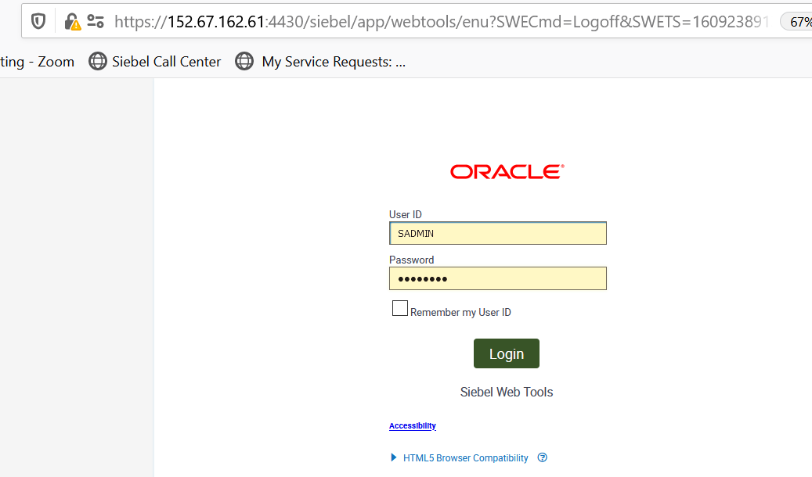

1. Select **Business Object**. In the filter search for Name - Filter for Account*. In the OE, expand Business Object and click Business Object Component.

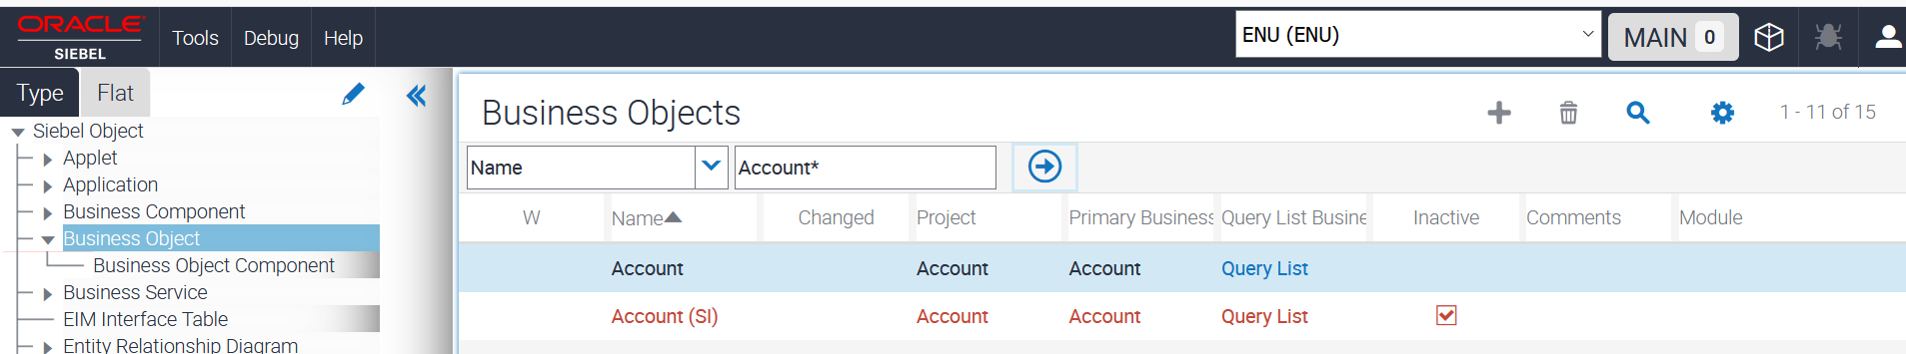

1. In the bottom applet, verify that there are several business components (BCs) that are part of this business object (BO). In the bottom applet, query for Bus Comp = CUT Address. CUT is an acronym for Communications Utilities.

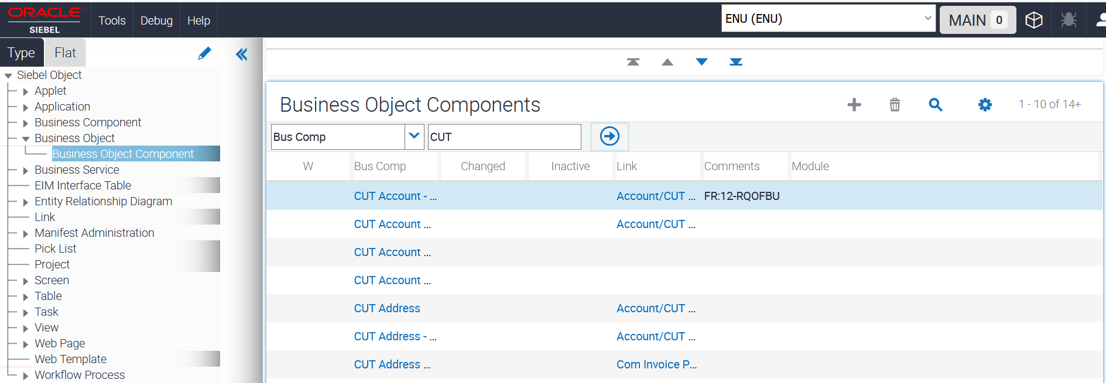

1. Examine the structure the included business components.
   1. Drill down on CUT Address.
   2. In the OE, expand Business Component and click **Field**.
   3. Notice that there are many fields in this BC.
   4. In the top applet, query for Name = Account.
   5. In the bottom applet, repeatedly click in the vertical scroll bar to scroll to the bottom of the list. You will see that there are many fields in this BC.

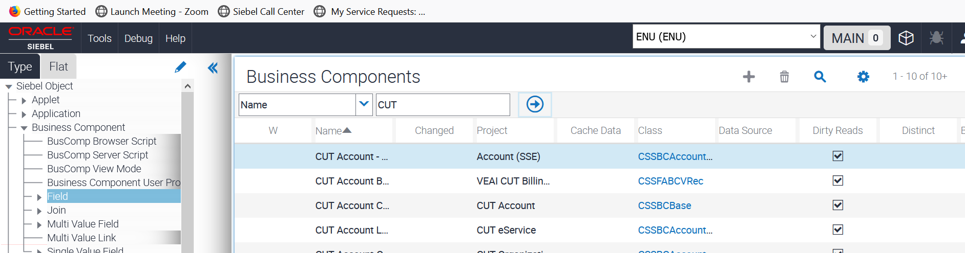

1. Exploring the Business Service.
   1. In the Object Explorer, click **Business Service**.
   2. Query for Name = eTraining Test Engine Service, click the Run (🡪)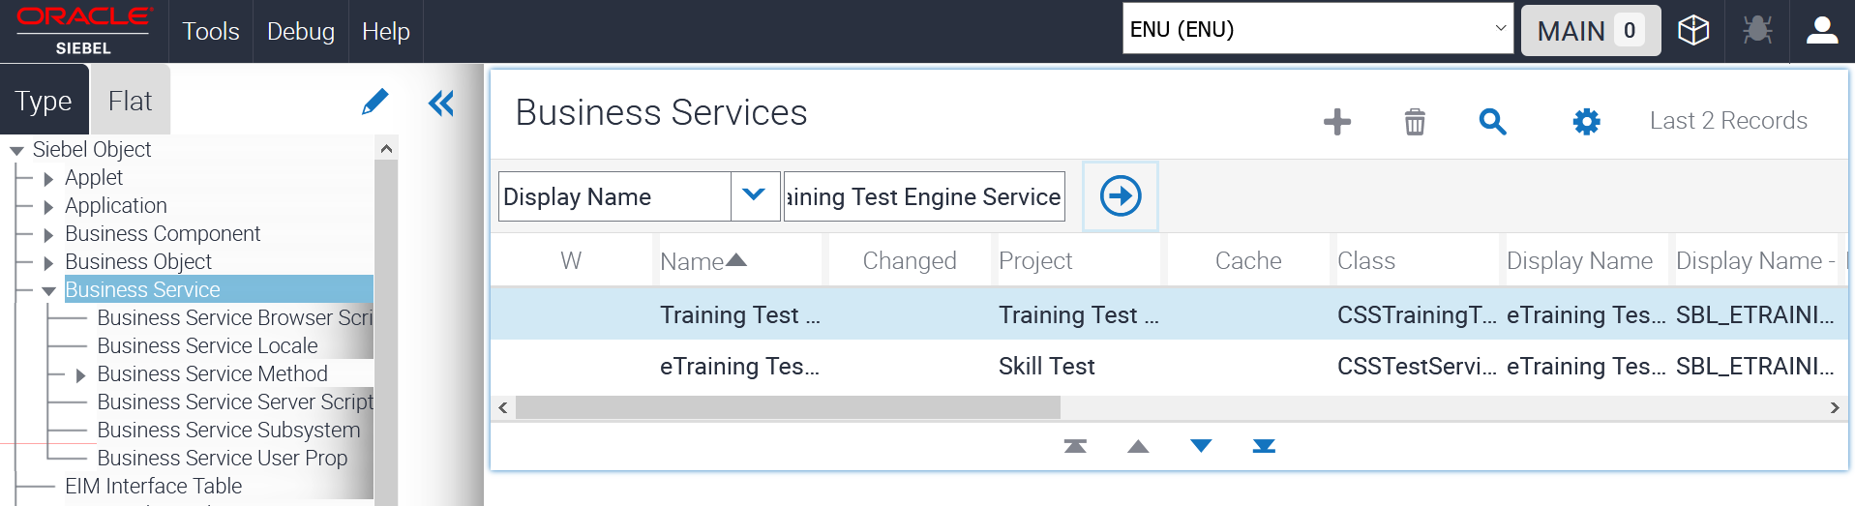
2. Choose the Record with **Project as Skill Test.**

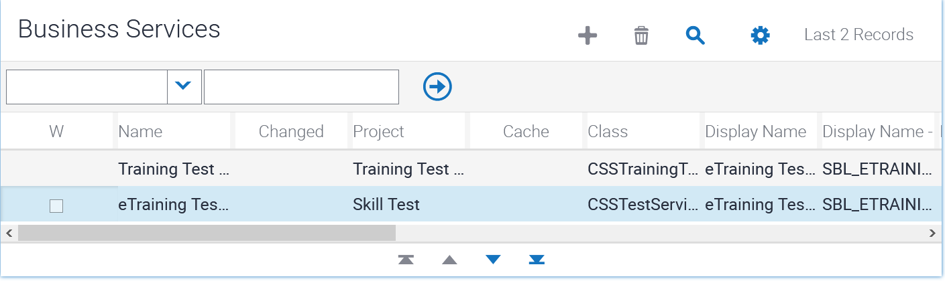

1. Choose the Business Service Methods from Object Explorer. You will be able to view the methods down the down-applet as below.

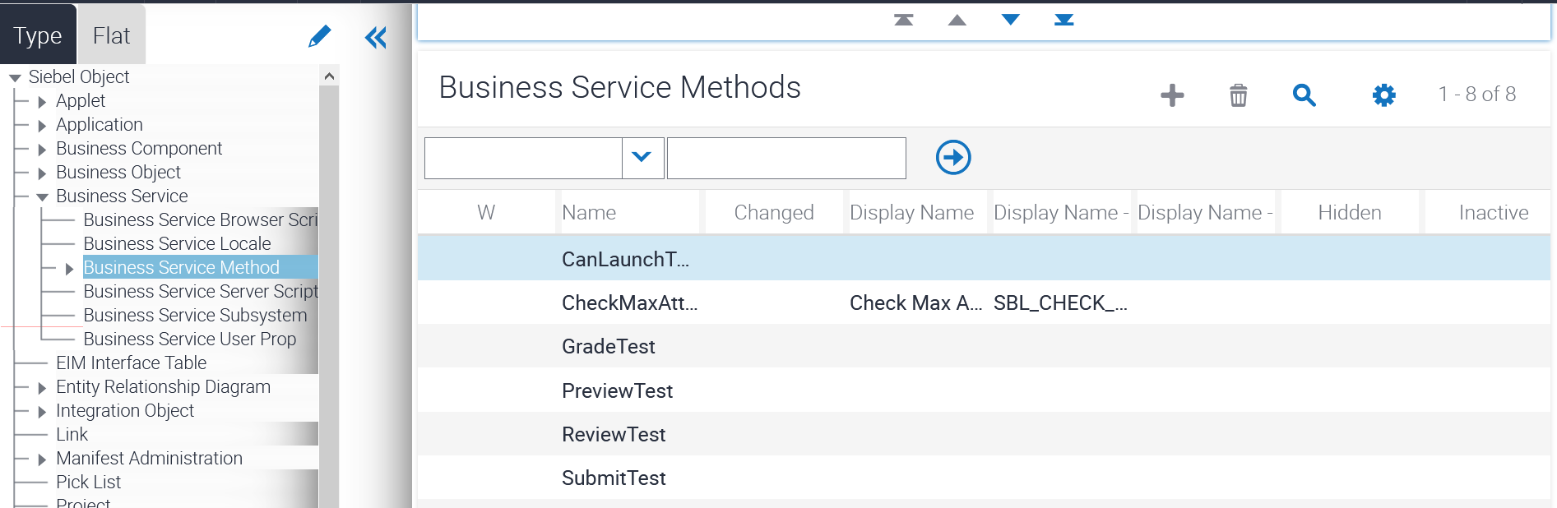

1. Now, click on CheckMaxAttempts from the Service Methods. Expand the Business Service Method from Object explorer. Choose the Business Method Arguments. The down applet will show the attribute details as below.

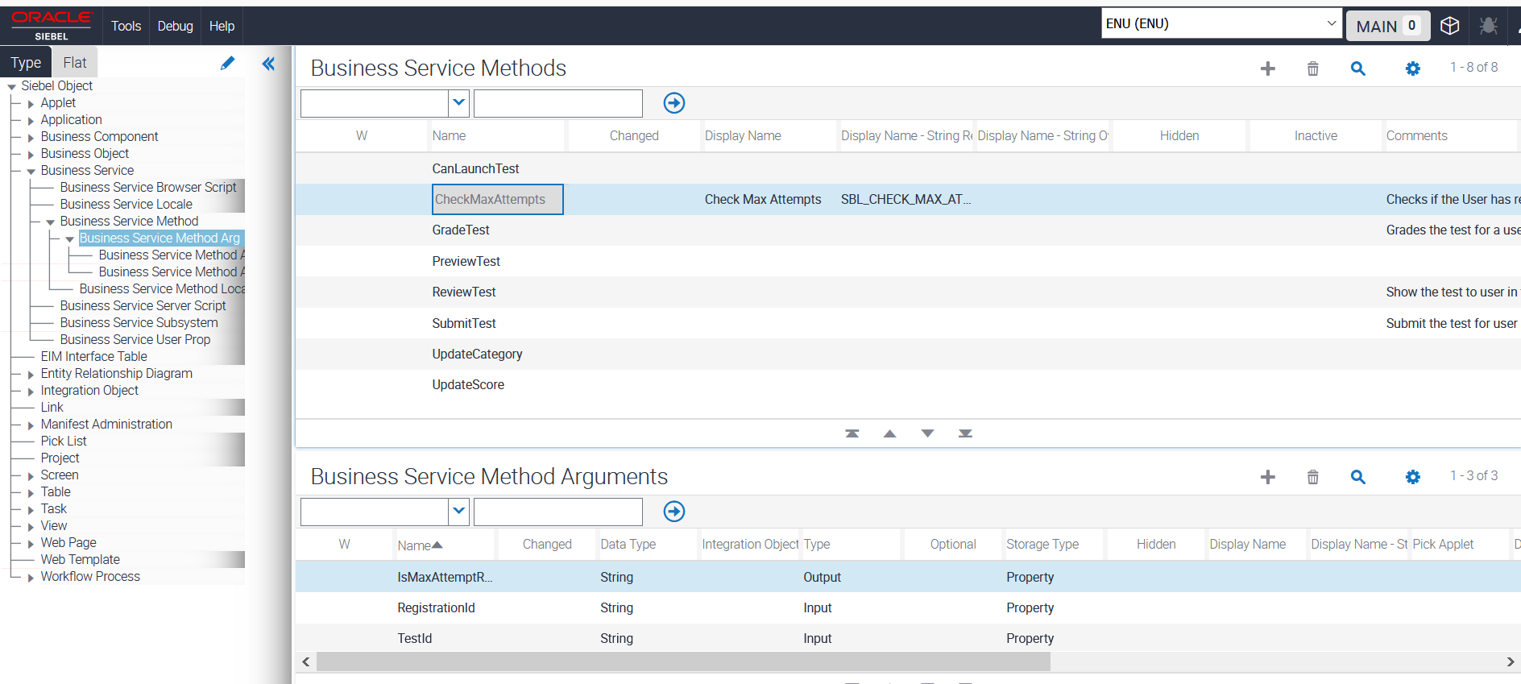

1. In the Object Navigator, choose **Business Services**. In the Right Side of the Frame, choose **Server Enabled,** Filter for Y as shown below.

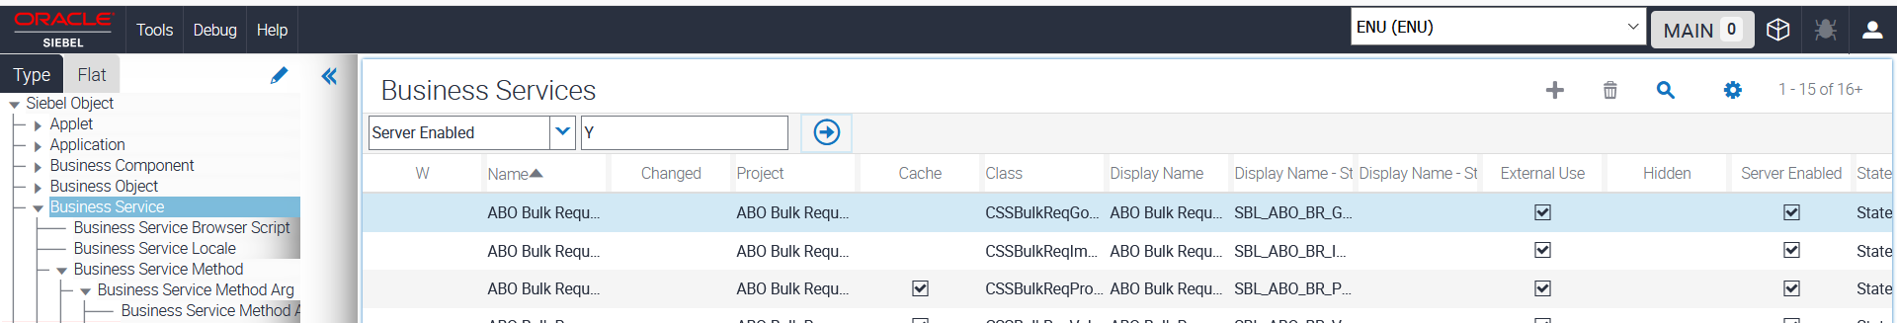

1. The Applet shows the list of Business Services which are server enabled. You can see that the Column Server Enabled – All Checked.
2. To find out the code of some of the server-side scripts, click on the **Flat View** of Object explorer and choose **Business Service Server** **Script** as shown below.

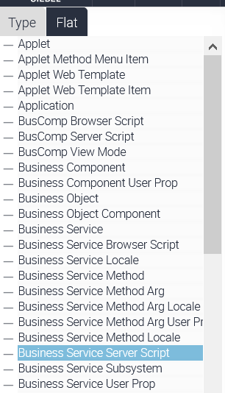

1. The list of Server-side scripts with name will be displayed in the right side of the applet frame. Once the mouse is moved over the Script column of selected record, the server- side script is displayed.

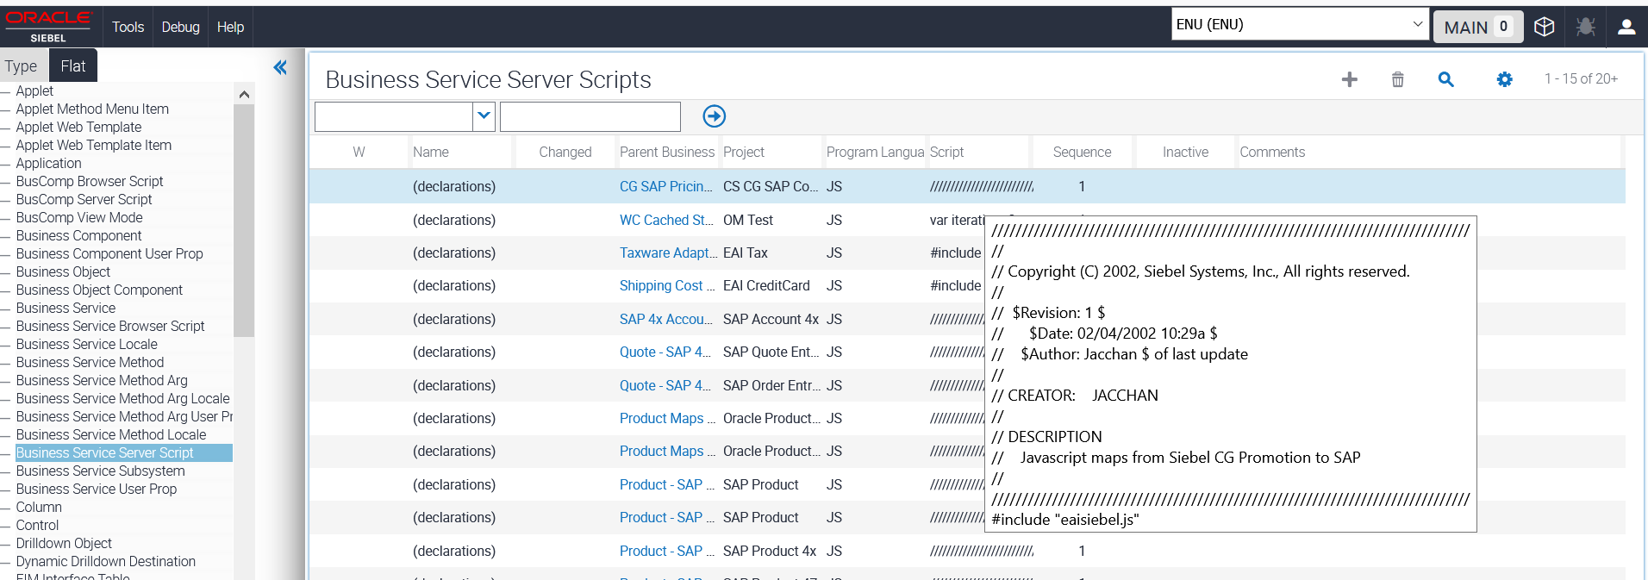

**Note:** Similar to Server-side script, you can view client-side scripts by clicking on Browser Scripts.

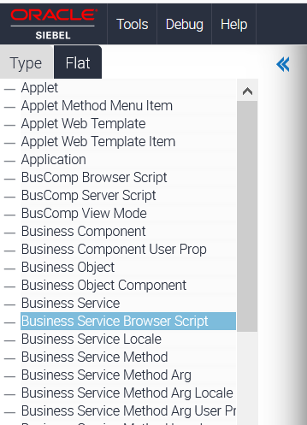

1. Choose **Flat** and choose **Business Service Browser Script**. As the mouse is rolled over the script column, the client-side script details are displayed as shown below.

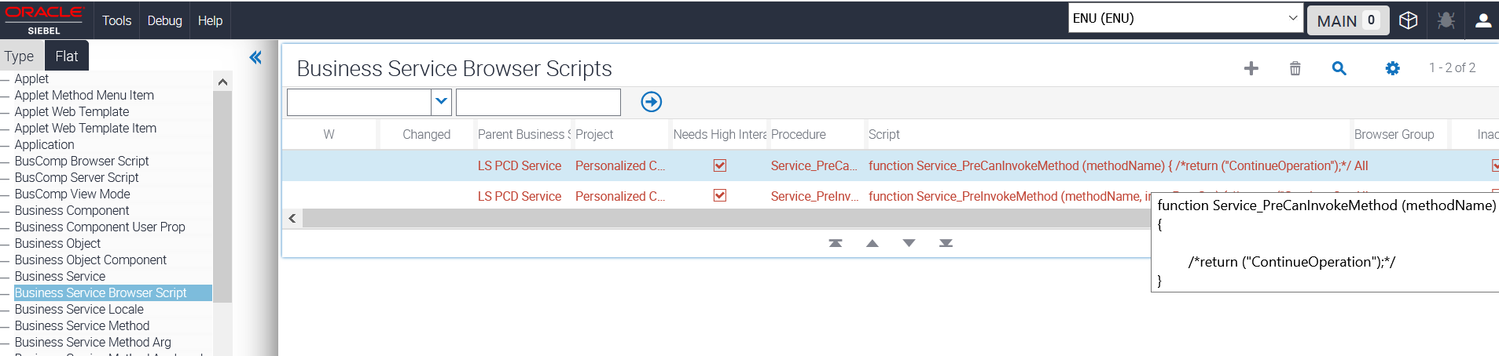

Activity 12-2: Testing Siebel Business Processes

**Overview**

In this practice, you willexplore Declarative Automation in Siebel Process Automation.

Assumptions

You should have completed the Practice 12-1.

Tasks

1. Log into App URL or Callcenter with Username and Password.

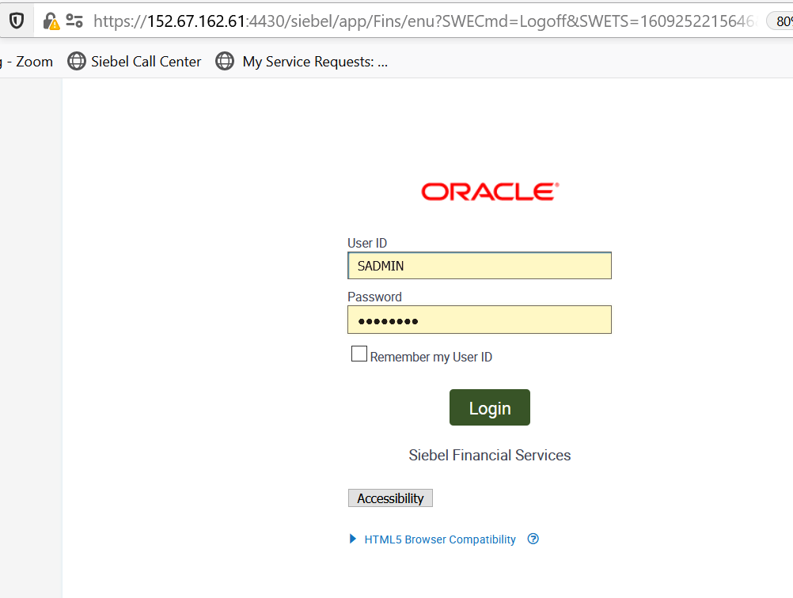

1. From the Console Site Map, navigate to **Administration** and to **State Models** as shown below.

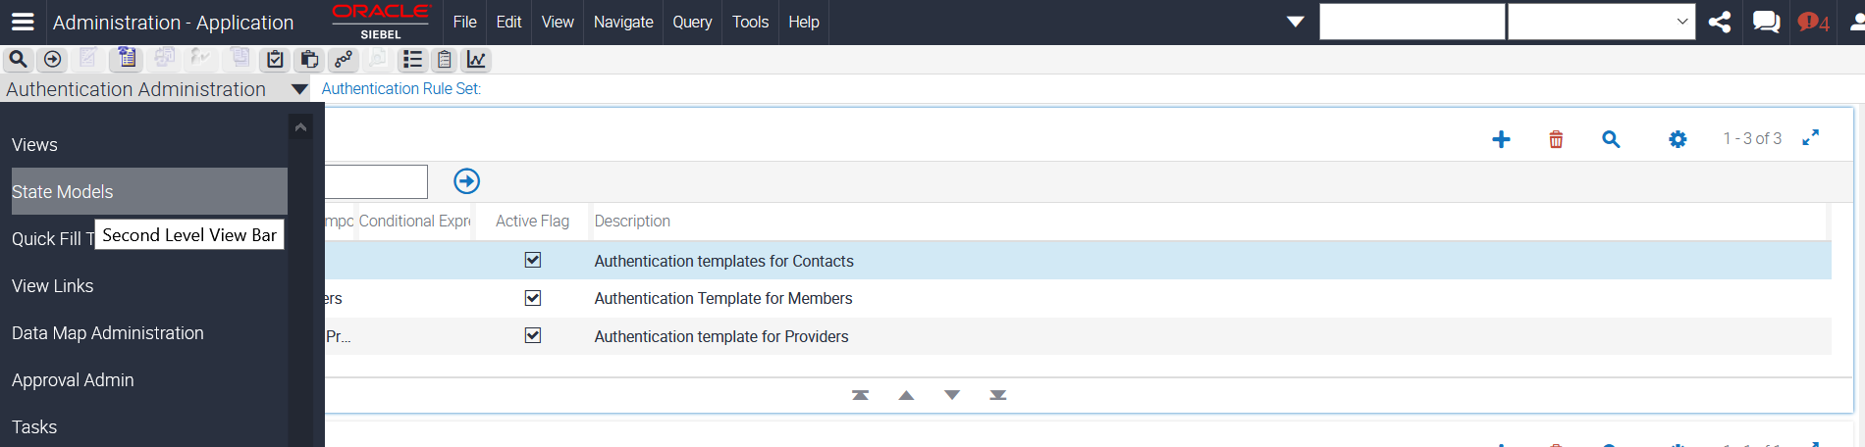

1. Provide Query for Name as **Expense** verify that the Field is **Status** as shown below.

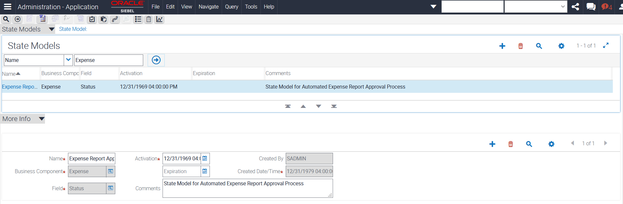

1. Drill down on the Expense Report Approval. Verify that the list applet shows various states (or values for this field).

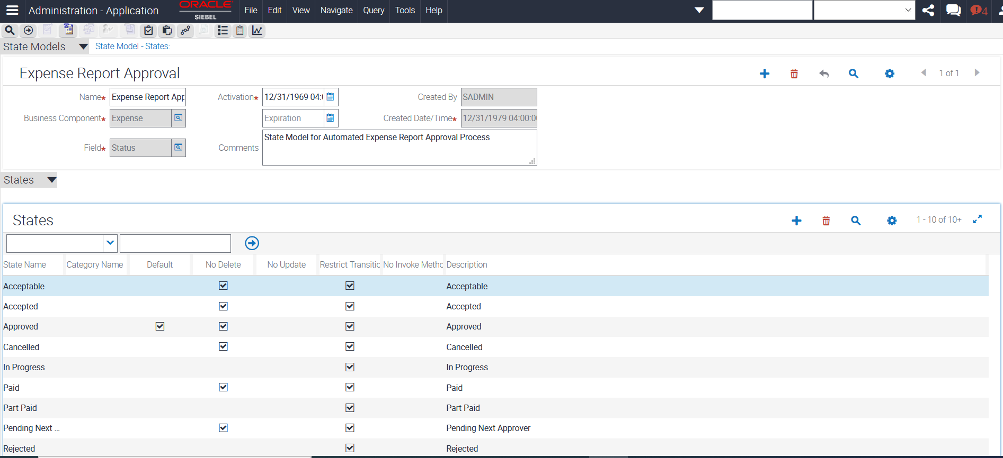

1. Click the Transitions view tab.

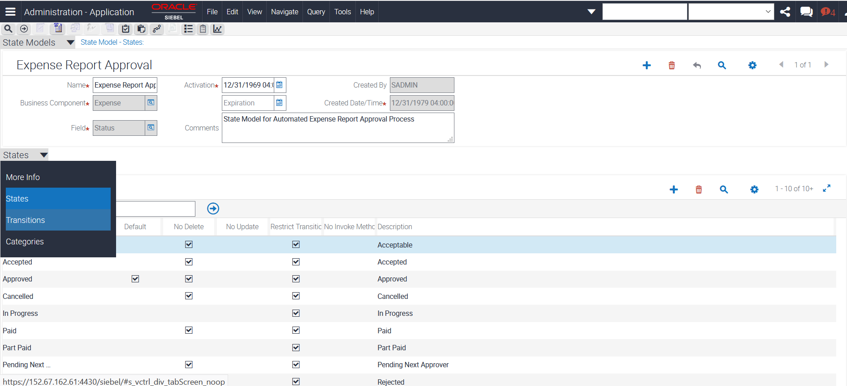

1. Verify that it lists "From State" and "To State" that controls which value, a user can change the field to when the field is in a certain state.

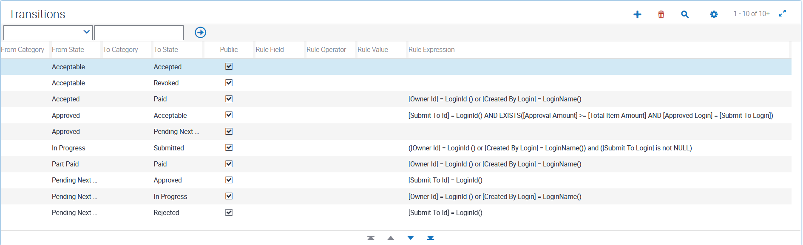

**Note:** All these rules are "declarative". You enter data into the application. You do not have to write any code or use Siebel Tools.

**Inspect Assignment Manager**

1. Navigate to Site Map - Administration - Assignment > Assignment Rules List.



1. Query for Name = "Territory 8". Note: Include the quotation marks.

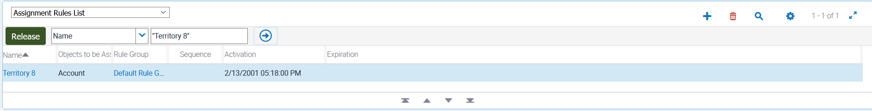

1. Drill down on Name (Territory 8).

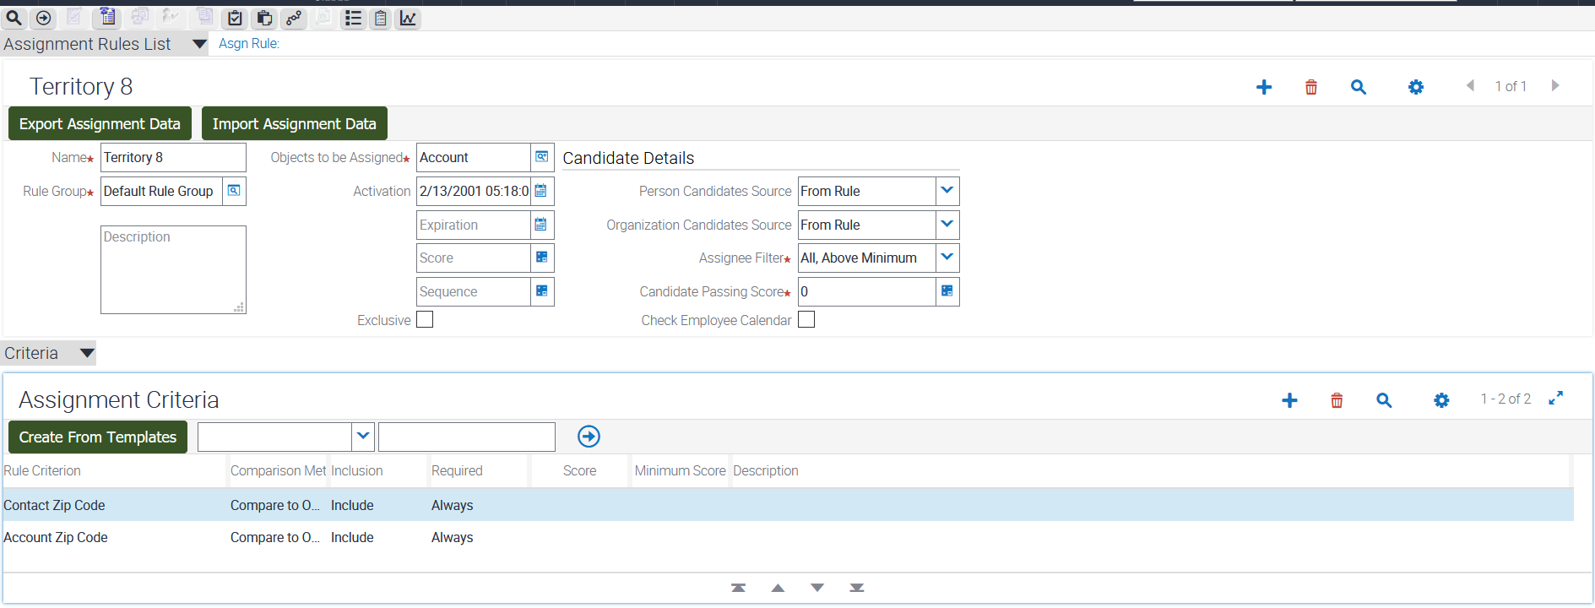

1. Verify that "Objects to be Assigned" = Account. This rule deals with assigning account data.
2. In the middle "Criteria" applet, check that one of the criterions is "Contact Zip Code".
3. Scroll down to the bottom applet. You will see various zip codes are listed. This rule is going to assign account data based on zip codes.

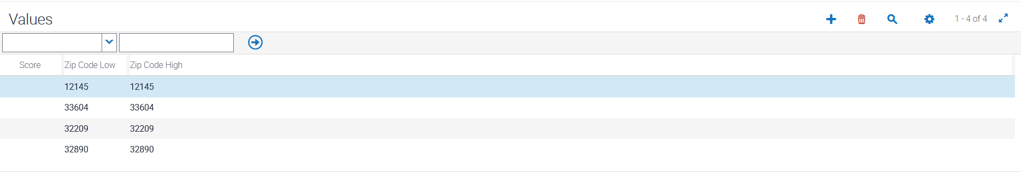

1. Verify again that these rules are "declarative". You enter data into the application. You do not have to write any code or use Siebel Tools.

Practice 12-3: Test the Service through Business Simulator

**Overview**

In this practice, we will test an existing service through business simulator.

Assumptions

You should have completed the Practice 12-2.

Tasks

1. From the APP URL or through the call center URL – Visit the Site Map and access the following. (https://public-ip-address:4430/siebel/app/sales/enu)
2. Navigate to the Administration - Business Service screen, Simulator view.

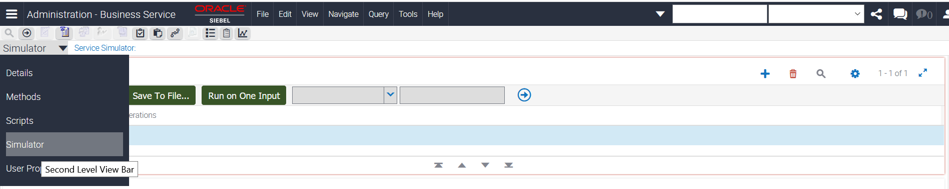

1. Click on (+) on the Screen for Simulator

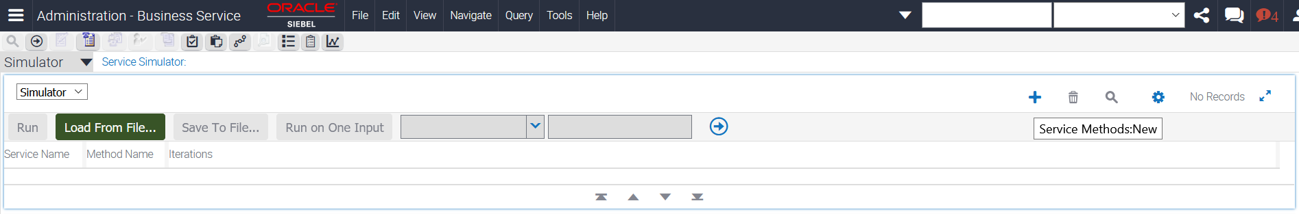

1. Choose the Service name by clicking the Search Button in the Service Name field and choose **eTraining Test Service.** Click **OK** to continue

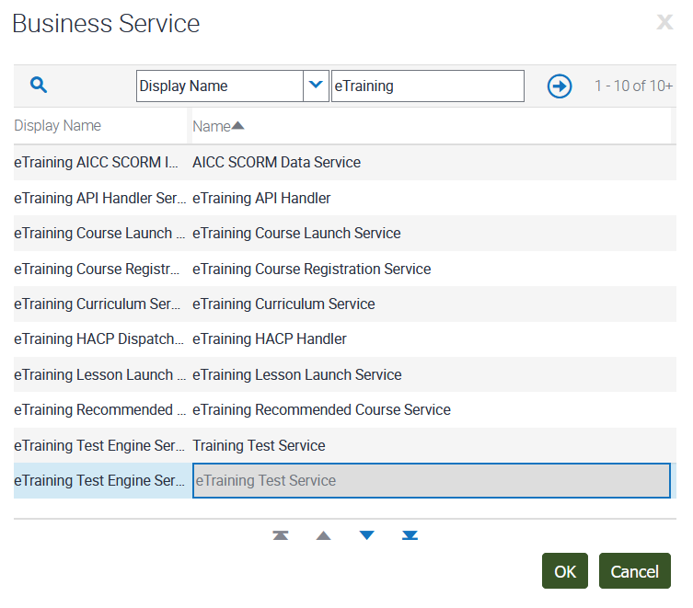

1. In the method Name, click on Search Button and choose the Function – **CanLaunchTest** as shown below.

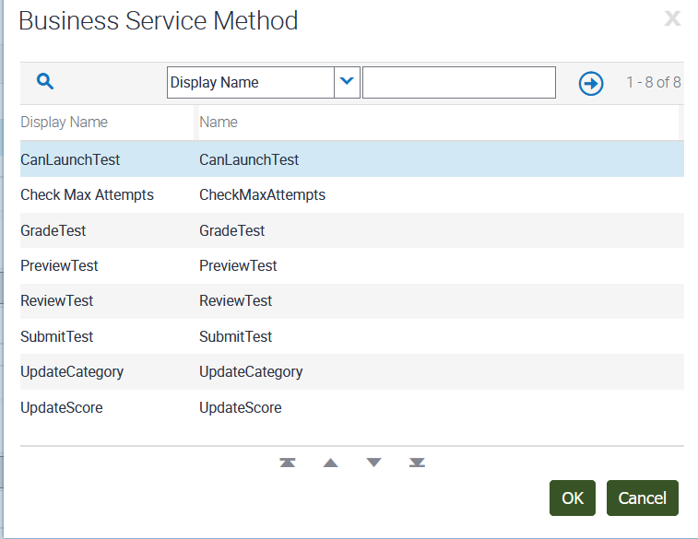

1. Choose the number of Iterations as 2 and click **Run**.

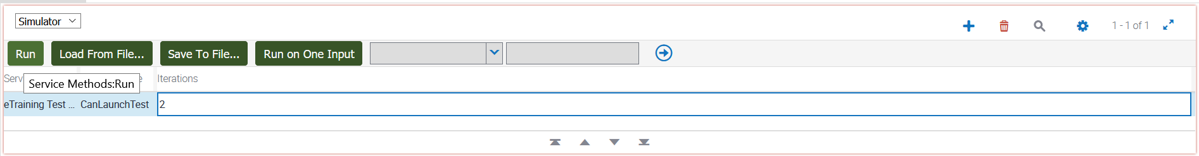

1. The Simulator runs the specified number of iterations and loops through the test cases in order. If you have defined multiple input arguments, you can choose to run only one argument at a time by clicking Run On One Input. The result appears in the Output Property Set applet.
2. When the Output arguments are created, click **Move To Input** to test the outputs as inputs to another method.